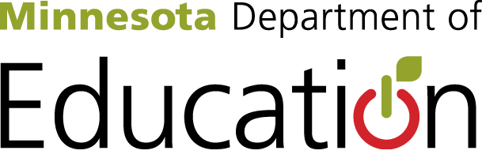

Federal ABE Application Local Workforce Development Board Review
Instructions: Please review your region’s/group’s local applications for federal Adult Basic Education funding, especially the “Collaboration and Contextualization” section. Once you have read the plan, complete this review form (one per applicant) and submit to Cherie Eichinger at Cherie.eichinger@state.mn.us by 10:00am on April 10, 2017.

Applicant: (ENTER APPLICANT ORGANIZATION NAME HERE)

Question 1
Who is the primary representative leading the WIOA Title II application review from the local workforce development board?
Name:
Email:
Phone:

Question 2
Which additional local workforce development board representative(s) participated in the review?

Question 3
How well does the application align to your local and regional workforce development plan? (check one)
Highly Aligned
Moderately Aligned
Little to No Alignment

Question 4
What specific parts in the reviewed sections of the application align to the local and regional workforce development plans?

Question 5
What additional strengths do you see in this application?

Question 6
What specific recommendations do you have about this application, including recommendations to improve alignment to the local or regional workforce development plan?

Question 7
What questions do you have about this application?

