Minnesota ABE Content Standards Reference (read more at http://atlasabe.org/professional/content-standards)

MN ABE Content Standards Model | College and Career Readiness Standards
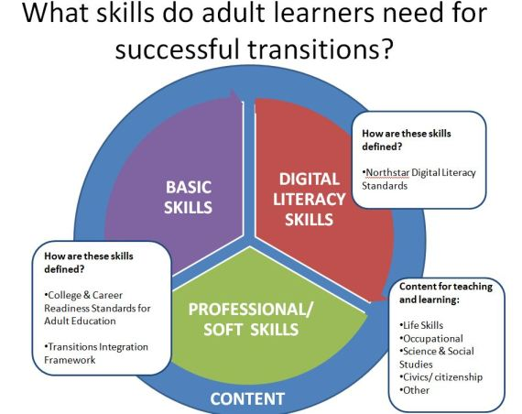 | English Language Arts (ELA) and Literacy  - Key Instructional Shifts  - Complexity  - Evidence  - Knowledge  - Reading Standards levels A - E  - Writing Standards levels A - E  - Speaking and Listening levels A - E  - Foundational Reading Standards levels A - C  Mathematics  - Key Instructional Shifts  - Focus  - Coherence  - Rigor  - Standards for Mathematical Practice (Math Practices) 1 - 8  - Mathematics Standards levels A - E
ACES Transitions Integration Framework | Northstar Digital Literacy Standards
Effective Communication  Learning Strategies  Critical Thinking  Self-Management  Developing a Future Pathway  Navigating Systems | Basic Computer Skills  Mac OS X  World Wide Web  Email  Windows | Word  Social Media  Excel  PowerPoint  Information Literacy

