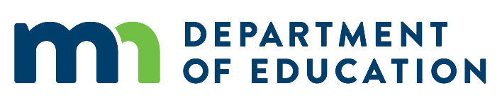

Adult Basic Education Navigating and Advising

Support Services Legislative Grant

Grant funds must be expended by June 30, 2019. Complete this report after all grant funds have been expended, no later than July 15, 2019. Submit via email to [Cherie.Eichinger@state.mn.us](mailto:Cherie.Eichinger@state.mn.us) Please address the following items in a final report of three pages or less.

Please briefly describe your project.

This goal of this project was to develop a replicable volunteer navigator program for MN ABE. The project entailed defining the role of the navigator, developing a training program to prepare volunteers to fit this role, testing the training needs by conducting small, pilot programs, opening up the volunteer navigation training to the general public, and consulting with ABE programs on what the role entailed, and how to implement a navigation program using best practices learned along the way.

What were the implementation challenges?

Navigation was (and is) a very hot topic in the ABE world when this grant was started, but there was no consensus as to what a navigator should do. The scope was very broad, and the challenge lay in providing a service that was beneficial to learners, fairly easy to implement and not costly.

What were the successes in implementation?

We developed a 6-hour volunteer navigator training program and have built this training into MLC’s menu of volunteer training this year. We trained more than 85 volunteers to serve in the navigator role and 22 coordinators/lead teachers went through the Implementation training we developed. At least 10 sites have implemented or are in the process of implementing volunteer navigation programs. Many students have benefited already – from increased confidence in reading/speaking, to better jobs, to feeling a sense of belonging at their school, to understanding career and educational choices, to improved test scores and discovering they have a voice in their future.

What were the lessons learned from this implementation?

Things we learned include:

* The relationship between student and navigator is key. This relationship is more important in helping students persist and engage in education than any specific goals the student and navigator might work on;
* Students do best when goals are broken down into very small, achievable (in a month or less) mini-goals;
* The navigator plays a key role in being a “cheerleader”; pointing out what a student has improved on, what he or she has learned, even noticing and pointing out if a student has changed their attitude towards their education;
* Navigation is a combination of building a relationship, setting goals, working together to accomplish those goals (which may involve teaching test-taking and study skills), and providing a metacognitive view to the student of how their skills have improved or attitudes have changed.

Please identify any promising practices, tools, resources, materials and/or recommendations for colleagues in the field to use?

* Six-hour volunteer navigator training held quarterly at MLC;
* A two-hour distance learning video focusing on Active Listening and Goal Setting (in final stages of development/testing);
* Recruitment of volunteer navigators built into MLC volunteer outreach activities;
* Navigation Start-Up Tools for volunteer coordinators (this is currently in paper form, but will be added to the MLC website).

Please identify a contact person (name, email, phone number) for any questions regarding this project:

Cathy Grady, [cgrady@mnliteracy.org](mailto:cgrady@mnliteracy.org); 651-251-9068.