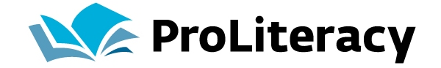
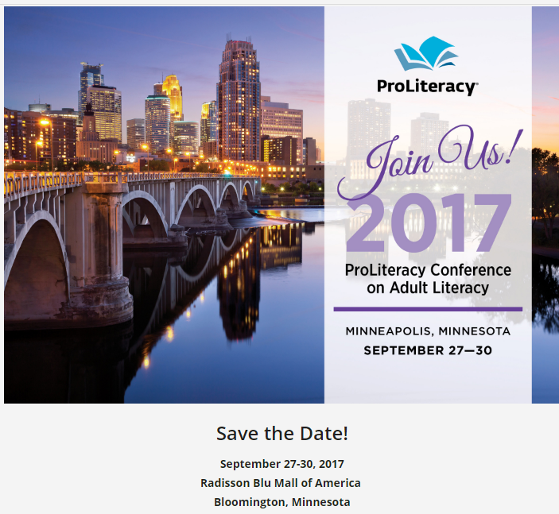
ProLiteracy is the largest adult literacy and basic education membership organization in the nation and has been working across the globe for the past 60 years to create a world where every person can read and write.
Attend
For information about registration, please visit:
https://proliteracy.org/Professional-Development/ProLiteracy-Conference
Submit a presentation proposal
The planning team is seeking presentations that explore how organizations and practitioners can work collaboratively to build instructional capacity and best deliver innovative, effective literacy services for the benefit of adult learners, their families and our communities. All proposals must be submitted online by January 13, 2017. Notifications will be made by March 31, 2017. Submit your proposal here: https://proliteracy.org/Professional-Development/ProLiteracy-Conference/Workshops
In past years, conference strands have included: instruction, fundraising/program management, training and PD, GED/HSE prep, technology/digital literacy, advocacy, adult learner involvement, partnerships, and ELL/immigration/citizenship.

