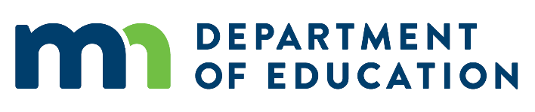

Statement on Approving Remote Testing
May 14, 2020
The Minnesota Department of Education’s Adult Education Office approves remote testing by ABE programs for accountability purposes, as long as it adheres to requirements set by test publishers and the U.S. Department of Education. Remote testing is a student taking a test from a different location than the test proctor. For state and federal ABE accountability purposes, this involves the student taking a test on a computer or approved device while being monitored by the proctor using approved live video methods. Tests that can currently be delivered remotely include: BEST Plus, CASAS, and TABE.
Remote testing requirements include:
- Student identification: Proctors must verify the student’s identity.
- Test security: Proctors must follow guidelines to ensure test questions remain secure.
- Remote proctor training: Proctors must have completed training on specifics of remote testing.
Resources for More Information
To learn more about remote testing, read information and details developed by the test publishers:
BEST Plus (http://www.cal.org/aea/bp/)
CASAS (https://www.casas.org)
- CASAS Going Live! Checklist (https://www.casas.org/product-overviews/software/casas-etests/-going-live-checklist)
- Remote Testing for CASAS tests (https://www.casas.org/product-overviews/remote-testing)
TABE (www.tabetest.com)
- TABE Online Quick Start Guide (http://www.tabetest.com/PDFs/TABE_OnlineQSG.pdf)
- TABE Remote Proctoring Webinar (https://tabetest.com/resources-2/tabe-webinar-series/)
- TABE Online Training Videos (https://tabetest.com/PDFs/TABE_11_12_OnlineTraining_Videos.pdf)
- TABE Remote Testing FAQs (http://tabetest.com/PDFs/TABE_Remote_Testing_FAQs.pdf)
Questions
If you have any questions about remote testing or test training, please contact Marty Olsen (martha.olsen@gmail.com).

If you have any questions or concerns about policy or this statement approving remote testing, please contact Brad Hasskamp (brad.hasskamp@state.mn.us).

Thank you.
Todd Wagner, State ABE Director
and
Brad Hasskamp, Adult Secondary Credential and Education Policy Specialist
Minnesota Department of Education

