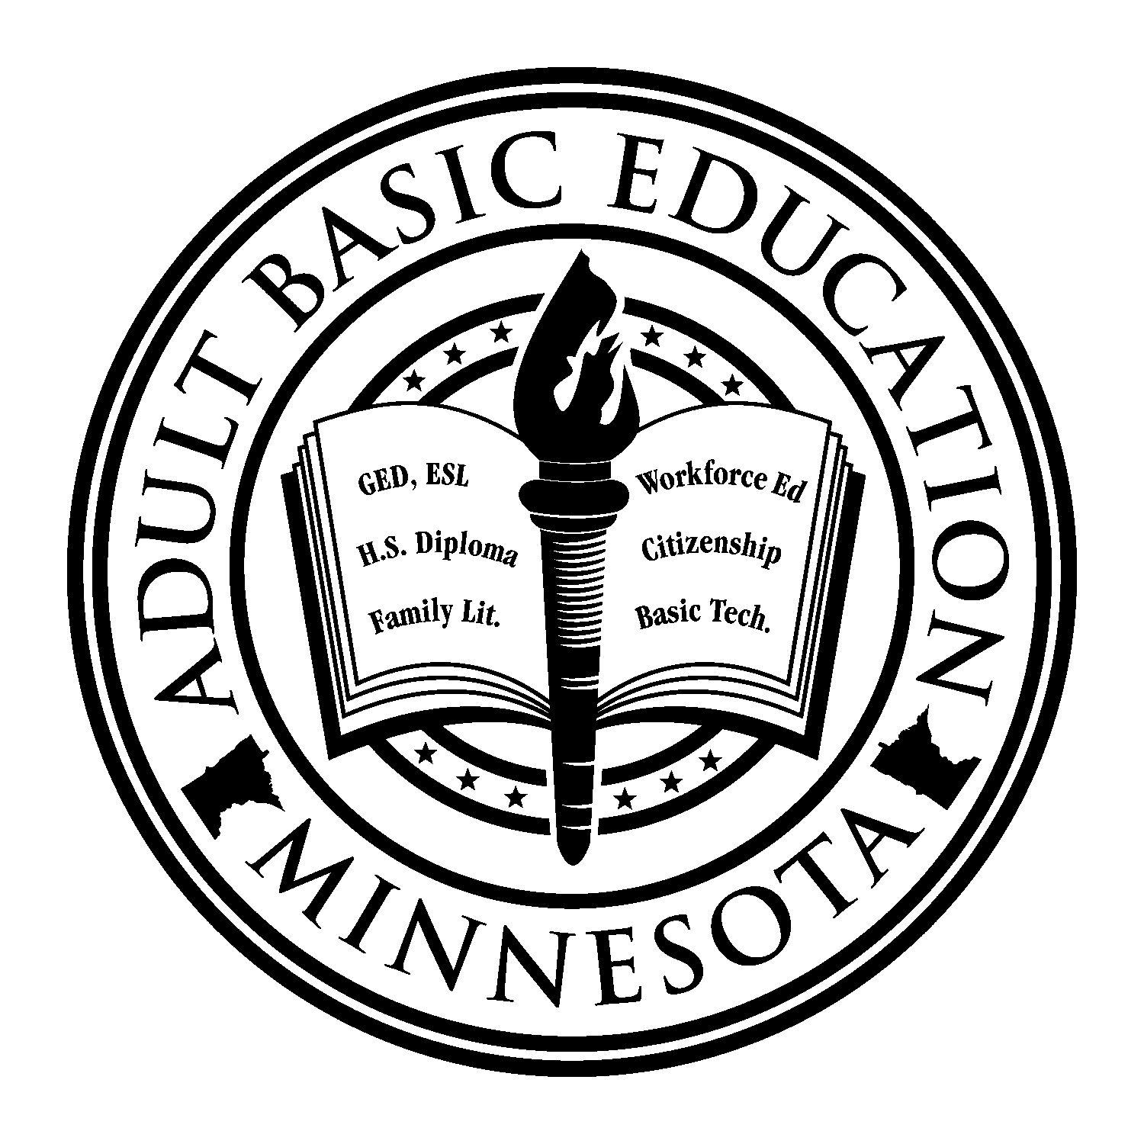

Minnesota Adult Basic Education:
ABE CONSORTIUM MEMBERSHIP
AND OPERATIONS

POLICY DEVELOPMENT DATE: April 20, 1999

POLICY IMPLEMENTATION DATE: May 1, 1999

LATEST POLICY REVISION DATE: December 7, 2010

POLICY PURPOSE:
This policy is needed to establish clear criteria regarding ABE consortium membership and the duration of such memberships. The policy is intended to value the ABE program approval process, the fiscal responsibility of an approved program, its district geographic boundaries, and a program's service delivery process.

DEFINITIONS:
- Evidence of membership: In order to be considered a member of an ABE consortium, an organization must be listed as a member of that consortium in the consortium’s approved ABE application.
- Duration of membership: Consortium membership applies for one year.
- Resident ABE program: The resident program is the school district that contains (geographically) the new program location. The resident program may enter into arrangements with the program provider to reimburse the program provider for its costs to deliver the service.

IMPLICATIONS:
- Once an organization has been included in an approved ABE application(s):
- Contact hours generated by the organization may be reported by the consortium to the State to generate ABE funds;
- The organization must report contact hours through that consortium for the duration of the ABE program year;
- The organization may join a new consortium only at the beginning of the subsequent program year;
- An organization that terminates membership in a consortium during the program year will not be able to submit contact hours to generate ABE funds from the date of termination until the date of joining a new consortium.
- Organizations that are not currently members of an ABE consortium may join a consortium at any time and may begin counting contact hours from the date membership begins.
- An approved ABE program, or a sub-grantee acting on that program's behalf, may provide services at a location (specific site) outside of its own school district boundaries ONLY IF those services are authorized by the "resident" ABE program and if the learner contact hours are counted/reported by the resident ABE program. As a workable alternative, the non-resident consortium may serve a student from another consortium if the non-resident consortium has a written agreement to do so with the resident consortium. (Programs that have established sites outside of their boundaries may "grandfather in" those sites if the site was in existence prior to January 1, 1999.)
Note: In the last sentence, the "site" must have been in existence with the partnership intact prior to the January 1 date - not merely in existence as a delivery site.

For More Information, Questions and Contacts – This policy, along with other ABE policies and resources, can be found online at http://mnabe.themlc.org.

Consortium application information for Minnesota Adult Basic Education can be found online at http://mnabe.themlc.org/grants.html.

For questions or consultative assistance regarding this policy, please contact Brad Hasskamp, ABE Policy and Operations Specialist, at (651) 582-8594 or brad.hasskamp@state.mn.us.

